**SKILL SWAP PLATFORM**

A MINI PROJECT REPORT

**INTERNET PROGRAMMING - CS19542**

Submitted By

**RUPALA N - (220701233)**

**BACHELOR OF ENGINEERING**

**IN**

**COMPUTER SCIENCE AND ENGINEERING**

**RAJALAKSHMI ENGINEERING COLLEGE (AUTONOMOUS)**

**THANDALAM**

**CHENNAI-602105**

**2023-2024**

**SKILL SWAP PLATFORM**

**INTRODUCTION:**

The Skill Swap platform is an innovative project aimed at creating a community-driven space where users can offer and request skills, promoting collaboration and growth in professional and personal areas. Inspired by platforms like LinkedIn and freelance marketplaces, Skill Swap differs by focusing on skill exchange instead of monetary transactions. This approach offers users a mutually beneficial environment to expand their capabilities, network, and career opportunities.

**ABSTRACT:**

The Skill Swap platform is a web-based application that enables users to exchange skills with others by acting as a bridge between individuals who have complementary skill sets. The platform allows users to create profiles that display their current skills and the skills they wish to acquire. Using this information, the system connects users based on their needs and offers a variety of tools to communicate and collaborate on learning. The platform supports real-time communication, peer-to-peer matching, and session scheduling to encourage a smooth exchange of skills between users.

**FEATURES:**

* New users can access the platform after the Sign Up process where as the normal users can access their profile through a login form.

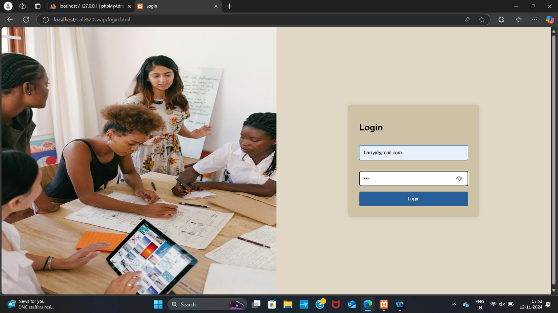

* The Sign up process requires the user’s name, email, password and confirm password sections.

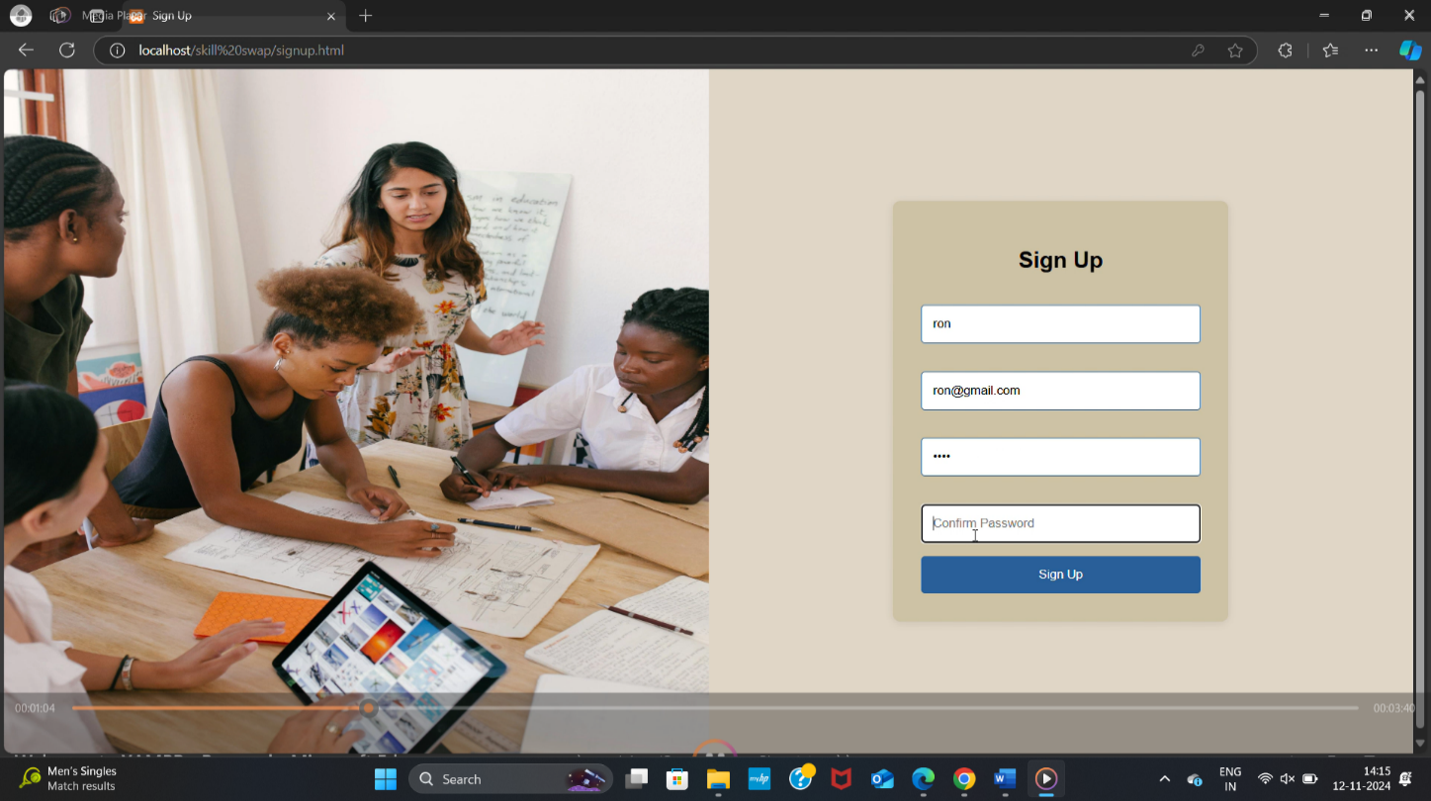

* Users can create detailed profiles that include a bio, the skills they can offer, and the skills they wish to learn.

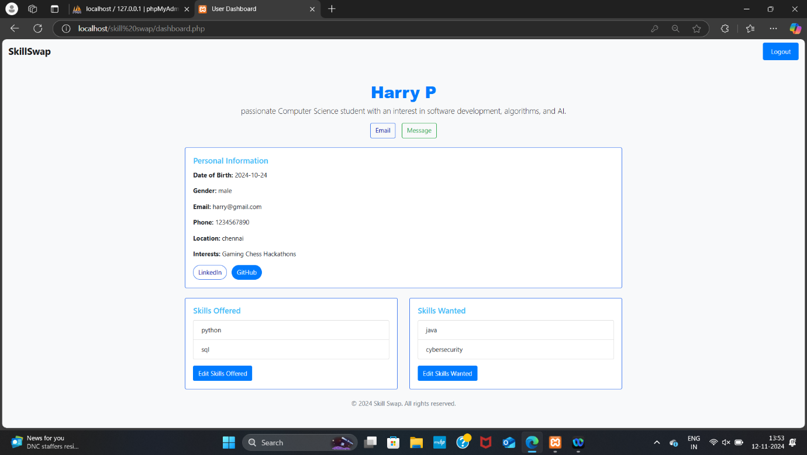

* First time users can enter their contact information and details through a form after the login process. The form is displayed below.

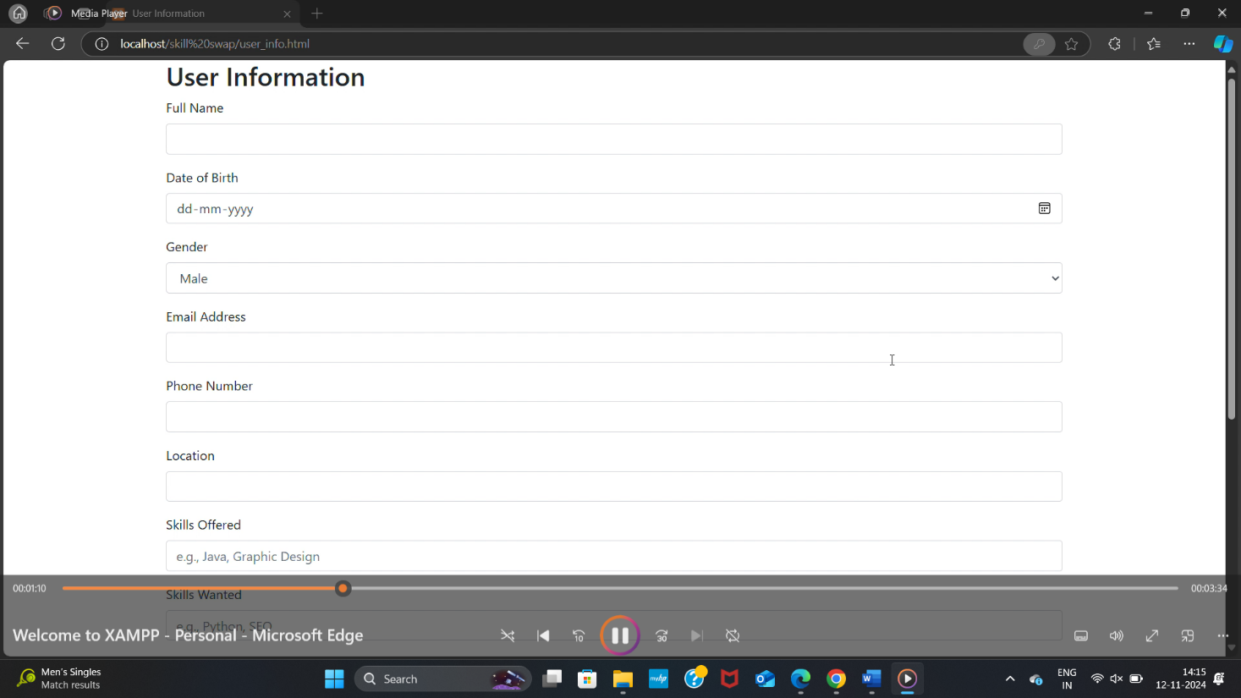

* Users have the ability to edit the skills they offer and skills they want throughout the journey in their profile page.

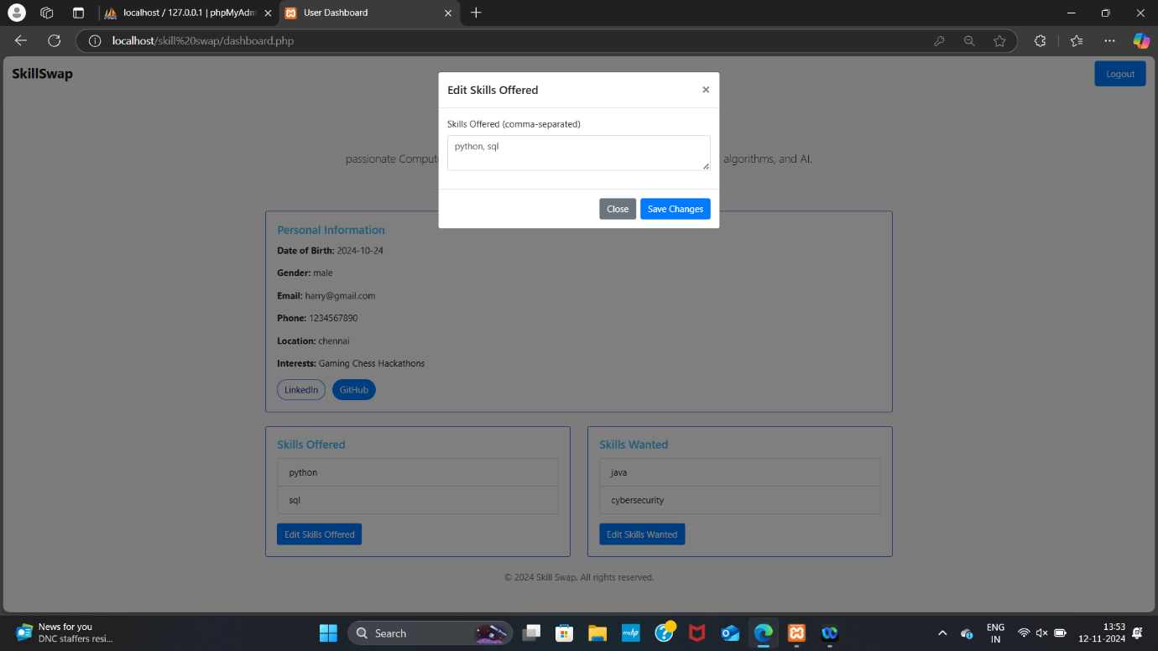

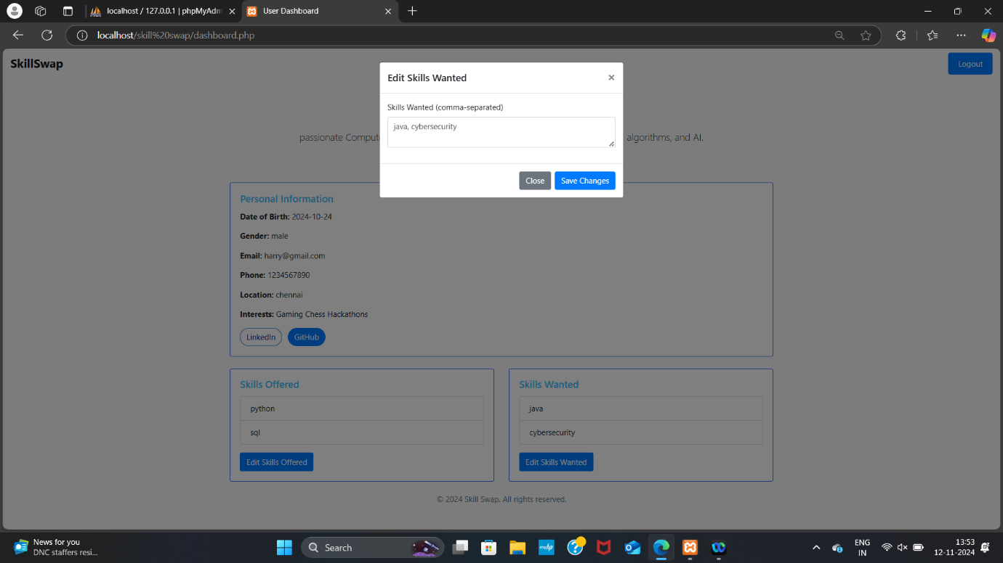

* The Home Page will contain all the information about the Skill Swap Platforms and testimonials of other customers.

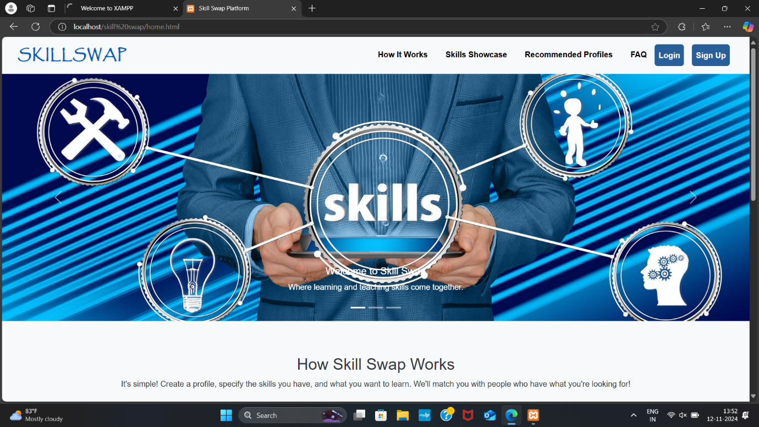

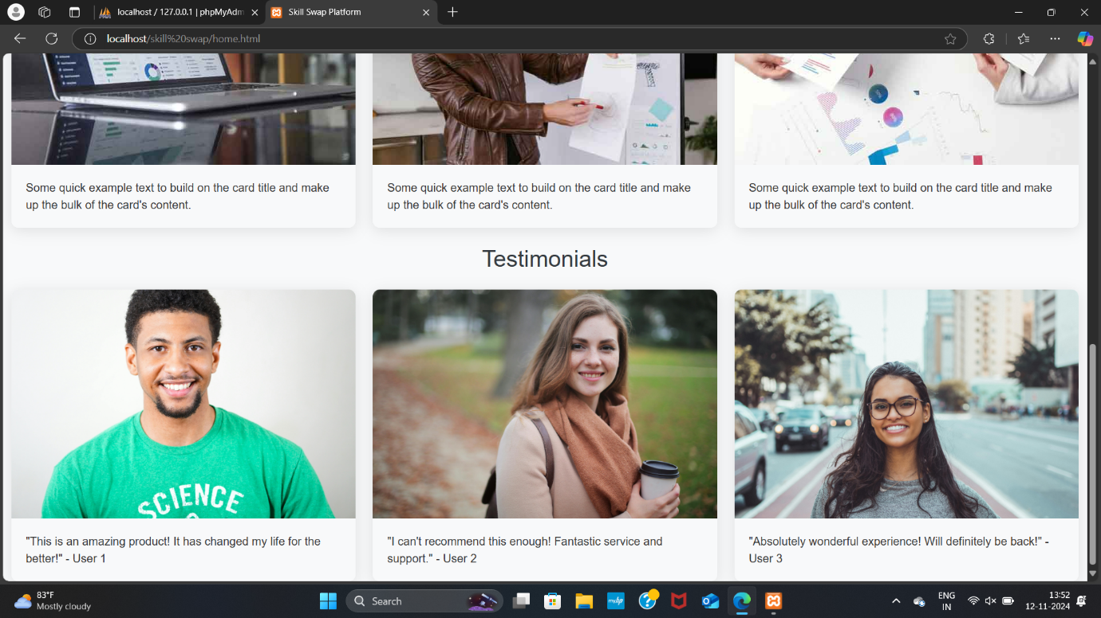

**SYSTEM ARCHITECTURE:**

**Database Design:**

The database comprises tables such as users, user_info, and sessions. These tables are interconnected to support complex queries, enabling features like skill matching and user searches.

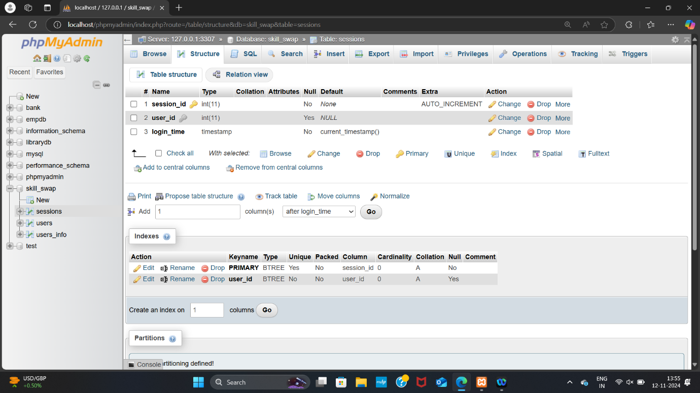

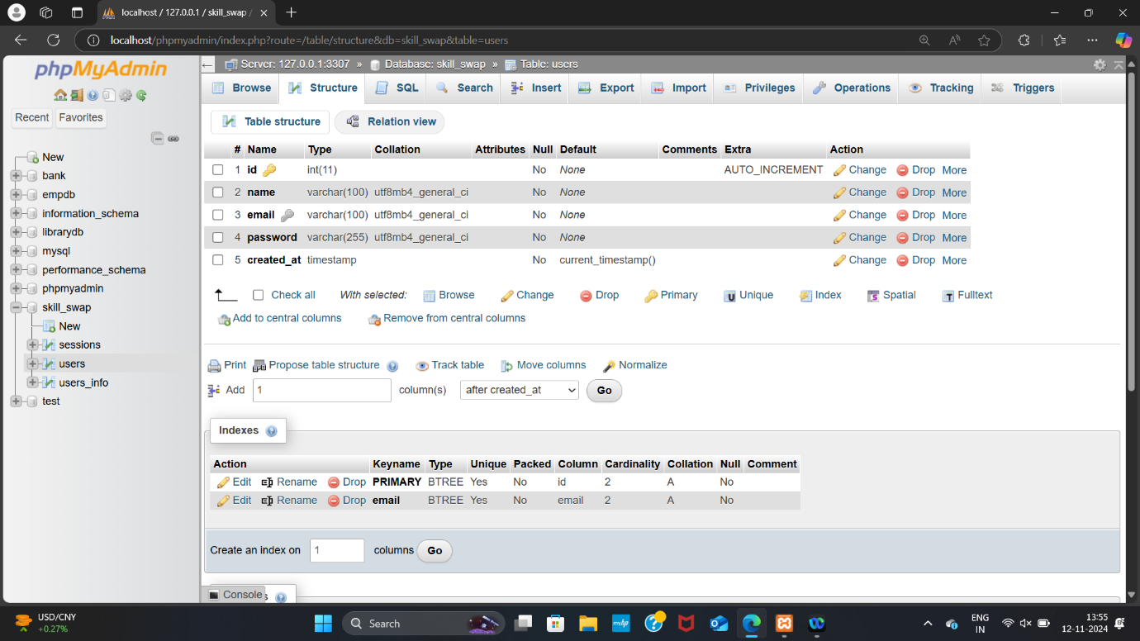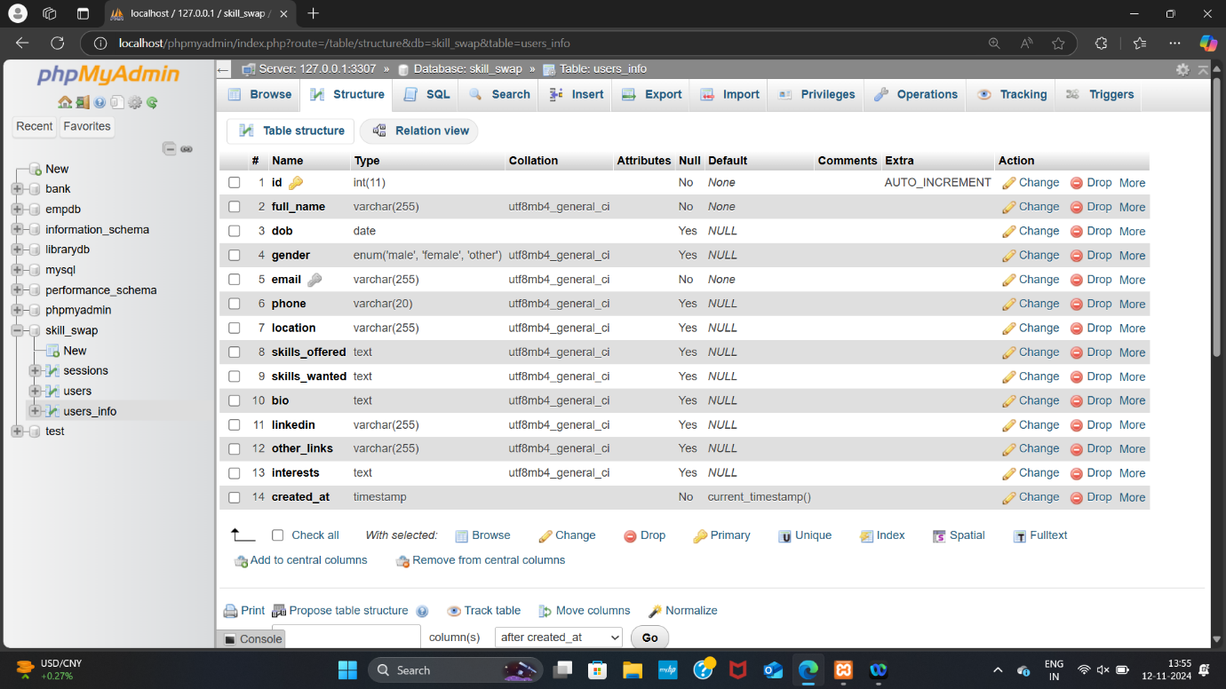

**UI/UX Design:**

The design approach was user-centered, ensuring ease of navigation. Elements like the navbar, profile cards, and messaging buttons were chosen to create a LinkedIn-style experience. The layout prioritizes key user actions, with responsive design for mobile compatibility.

1. **User-Centered Approach**:

* Design decisions were based on thorough research into user needs and preferences, particularly around usability and ease of navigation.
* Wireframes and prototypes were developed using tools like Figma to visualize the layout and ensure that the design met user expectations in terms of visual appeal and functional flow.
* Each component of the interface was created to support smooth interactions and intuitive navigation, ensuring users can focus on skill-sharing without unnecessary complexity.

2. **Navigation Elements**:

* The **navbar** prominently displays core navigation links, ensuring users can easily move between home, profile, dashboard, and logout options.
* A consistent color scheme of blue and white, with accents for important actions, reinforces a professional feel and provides a visually cohesive experience.
* The **Skill Swap logo** on the navbar is clickable, allowing users to quickly return to the homepage, which improves accessibility.

3. **Profile and Skill Cards**:

* **Profile Cards**: The user profile cards, a focal point of the interface, show key information like the user’s name, location, and skills, similar to LinkedIn's layout. Each profile card is visually distinct, with clear divisions between sections for offered and wanted skills, bio, and contact links.
* **Skill Display**: Skills are organized into bullet points within cards, allowing users to scan quickly through a list of skills rather than reading a text block. This design choice simplifies readability and allows users to easily recognize matches.
* **Messaging Buttons**: Integrated buttons for sending messages make initiating contact straightforward, a feature that supports smooth networking and collaboration.

4. **Layout and Accessibility**:

* The layout prioritizes key user actions, like updating profile information and searching for skills, placing these features prominently on the dashboard.
* Designed with responsive principles, the interface adapts smoothly to different screen sizes, providing a consistent experience on mobile and desktop.
* Buttons, icons, and text are sized to accommodate various devices, ensuring that all users, regardless of device, can interact with the platform effectively.

5. **Visual Aesthetic and Consistency**:

* Using Bootstrap’s grid system and pre-designed components, the interface maintains a professional and modern appearance while reducing development time.
* The color scheme of soft blue and white tones provides a calm, approachable interface that aligns with SkillSwap’s brand identity, while buttons and interactive elements use accent colors to draw attention to critical actions.

**DEVELOPMENT PHASES:**

**Requirement Analysis:**

For Skill Swap, this phase focused on identifying the key features, user expectations, and technical requirements essential to creating a functional skill-sharing platform.

**Process and Details:**

1. **Project Goals**: The core objectives were to design a platform where users could register, create profiles, list skills offered and desired, and connect with others. The team aimed to make the platform intuitive, secure, and user-friendly, encouraging both individual users and organizations to participate.
2. **User Flows**: Different user types were considered, such as students, professionals, and freelancers. Each type had specific needs and expectations:
   * **New User**: Register, complete a profile, and navigate the platform.
   * **Returning User**: Log in, update skills or profile information, and search for skill matches.
   * **User Searching for Skills**: Browse profiles, view specific skill offerings, and initiate connections.
3. **Security Requirements**: Skill Swap needed a secure environment to protect user data and interactions. Requirements included:

* **User Authentication**: Secure login and registration processes.
* **Data Protection**: Password hashing, encryption, and adherence to data protection standards.
* **Access Control**: Ensuring that only authenticated users could access certain features.
* **Session Management**: Prevent unauthorized session takeover and implement automatic session expiration.

**Prototyping and UI Development:**

The UI prototyping phase focused on building a visual blueprint for the platform. This stage ensured alignment with the intended user experience before the development phase began.

**UI Style Guide**: Based on the feedback, a UI style guide was established. It included font choices, color schemes (blue and white shades for a professional look), button styles, and spacing guidelines to maintain a consistent look and feel across the platform.

**Backend Development:**

Backend development involved creating the server-side architecture that powers the platform's core functionality, including authentication, profile management, and data storage. This phase ensured data integrity and smooth handling of user requests.

1. **Setting Up the Database**: A MySQL database was designed with essential tables for storing user details, skills offered and wanted, and session data. Key tables included:

* **Users Table**: For storing login credentials and basic user details.
* **User Information Table**: For additional profile details, such as bio, interests, and skill listings.
* **Skills Table**: A separate table for skills, ensuring flexible and scalable skill management.

Database schema design prioritized efficient query handling, with foreign keys linking tables and indexes for optimized searches.

1. **Server-Side Scripting**: PHP was used to write server-side scripts for various functions:

* **User Registration and Login**: Scripts verified user inputs, hashed passwords, and managed sessions.
* **Profile Management**: PHP scripts enabled users to update their profiles and skill lists.
* **Skill Matching**: The matching algorithm, implemented in PHP, compared skills offered and desired, filtered by parameters like location.

1. **Session and Security Management**: Session handling was implemented to manage user logins. Features like password hashing and CSRF token generation were added to enhance security, ensuring that unauthorized users couldn’t access sensitive data.

**Frontend Development:**

Frontend development focused on building a responsive, interactive user interface that aligned with the designs created in the prototyping phase. The goal was to create a layout that works seamlessly on both desktop and mobile devices.

1. **HTML Structure**: HTML was used to structure each page, defining the placement of elements such as the navigation bar, profile cards, and search filters.

2. **Styling with CSS and Bootstrap**: A combination of custom CSS and Bootstrap classes was applied to create a professional and clean interface.

* **Responsive Design**: Bootstrap’s grid system was used to ensure the platform adjusted to various screen sizes.
* **Interactive Elements**: Buttons, dropdowns, and cards used Bootstrap styling for consistency. Cards were particularly effective for displaying user profiles and skill information in a clear, organized manner.
* **Custom CSS**: Although Bootstrap provided a foundation, custom CSS was used to fine-tune elements, achieving the platform’s blue-and-white theme and enhancing user engagement.

3. **JavaScript for Interactivity**: JavaScript and jQuery were added to create a more interactive experience:

* **Search Functionality**: Users could search for skills or other users in real time, with results updating dynamically.
* **Form Validation**: JavaScript was used to validate input fields, ensuring clean data entry and providing users with immediate feedback on errors.
* **Navigation and Alerts**: Logout and redirection functions were added to provide smooth navigation and feedback notifications.

1. **Testing and Debugging**: The frontend was rigorously tested across different browsers and devices to ensure consistency in user experience. Adjustments were made to address compatibility issues, layout inconsistencies, and loading times.

**TESTING STRATEGY:**

* **Unit Testing**: Individual components like the login and registration systems were tested to ensure accuracy.
* **Integration Testing**: Tested the functionality of skill search and session management, ensuring they interacted as expected.
* **Usability Testing**: User feedback was gathered to enhance UI flow, and adjustments were made to simplify navigation.

**CONCLUSION:**

In conclusion, the Skill Swap platform has been designed and developed as a comprehensive solution for connecting individuals and organizations through skill exchange, fostering a collaborative community. By focusing on user-centered design, robust backend functionalities, and secure data handling, Skill Swap provides an intuitive experience tailored to the needs of diverse users. Each phase of development, from requirement analysis to deployment, contributed to creating a platform that is not only functional but also scalable, maintainable, and adaptable for future enhancements.

Overall, Skill Swap stands as a promising tool for personal and professional development, offering users a space to share, learn, and grow by leveraging their unique skills. Future enhancements, based on user feedback and market demands, can ensure that Skill Swap continues to meet the evolving needs of its community, setting the stage for a lasting impact in the skill-sharing ecosystem.